

Submitted by : Spogmai Jan
Roll no : 2430 -0081
Submitted to : sir nouman asim

Computer networks
Open ended lab
TASK 01:
As a network administrator for a small enterprise with two departments. The company wants a secure, scalable, and manageable network using Cisco devices. Company has two branches, HQ and Branch A. HQ have two sub_departments, Sales (15 hosts) and HR (8 hosts). Branch A has departments, Staff (17 hosts) and IT (10 hosts). You have to design the network with IP 192.168.10.0 which will fulfill following requirements by using at least one Router. 1. Create VLANs and Ensure that communication occurs within the VLAN and HR communicate with IT department only, verify the connectivity. 2. Apply Telnet in HR department to control the network set the telnet password and enable password also, change the name of any device.

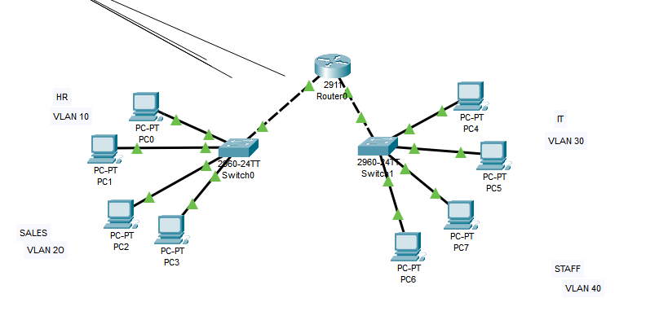

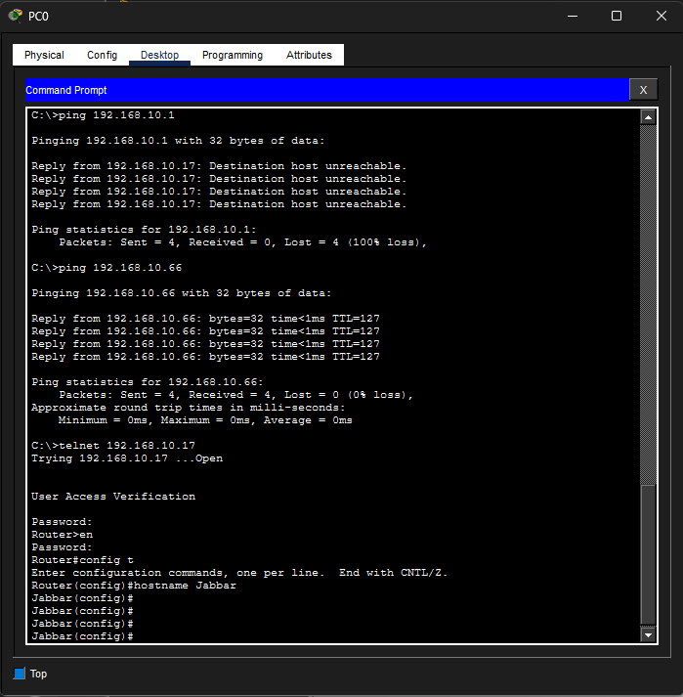

TASK 02:
The "TechFlow" Multi-Site Expansion. TechFlow Corp is expanding. They have a Main Office (HQ) and a small Remote Office. They need you to build a secure, scalable network that allows departments to communicate while keeping their data isolated. Business Requirements 1. Main Office (HQ): ∙ Management: 50 employees. ∙ Sales: 28 employees. ∙ Engineering: 14 employees. ∙ Server Farm: 1 DNS Server and 1 Web Server “Open Ended Lab”. 2. Remote Office: ∙ Staff: 25 employees. By using upper data you have to design a network with IP 192.168.50.0, and get the each host IP from DHCP server connected with Router0. Divide the network (subnetting) as given Subnet hosts.





